**Nagios – Monitoring Tool**

-it is used for monitoring the below points:

-cpu utilization issues

-disk space

-ssh service down

-host reachable or not

-network issue

-service or server is down

-no. of users logged in

-no. of processes running

-whenever we updating the changes of production servers like that downtime, we should not monitor as this is known activity, in this time we need to instruct the nagios for don’t monitor in that time (maintenance times)

-if we have new nodes, we need to register that in this tool for monitoring

-here also we have master and slave machine concepts

-all other systems are required to register in master machine to monitor

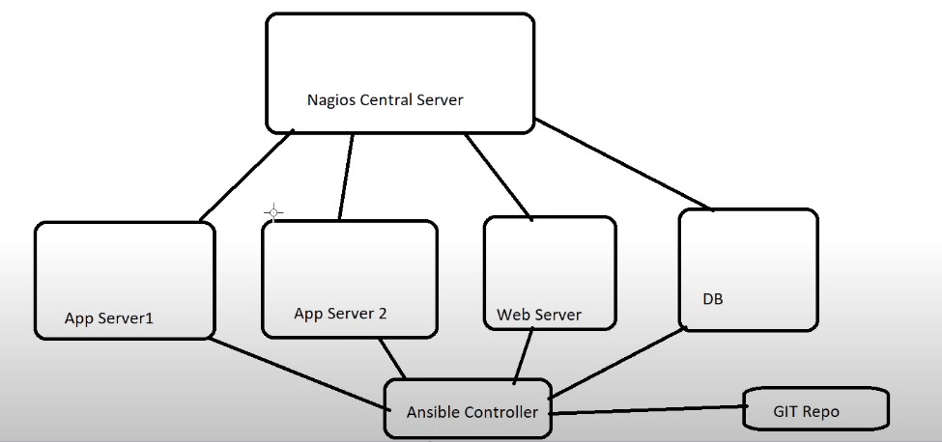

**Installation and configuration of Nagios**

-now we are going to install Nagios in Ubuntu system, if we use Linux system it will take lot of time to install and we need to install LAMP Stack (Linux, Apache, MySql, PHP) all packages separately, but in Ubuntu we can install all packages together with single package, so we are installing in Ubuntu for time saving.

Nagios is an open source software that can be used for network and infrastructure monitoring. Nagios will monitor servers, switches, applications and services. It alerts the System Administrator when something went wrong and also alerts back when the issues has been rectified.

Nagios is useful for keeping an inventory of your servers, and making sure your critical services are up and running. Using a monitoring system, like Nagios, is an essential tool for any production server environment.

With Nagios you can:

– Monitor your entire IT infrastructure.

– Identify problems before they occur.

– Know immediately when problems arise.

– Share availability data with stakeholders

– Detect security breaches.

– Plan and budget for IT upgrades.

– Reduce downtime and business losses.

Nagios:

-LAMP Stack

-Linux, Apache, MySql, PHP - Centos

-tasksel - Ubuntu

-tasksel installing all packages in single bundle

**Installing Nagios on Ubuntu:**

--> Use the tasksel to install the group of packages on ubuntu

$ sudo apt-get install tasksel

$ sudo tasksel (to start in GUI)

$ sudo tasksel install lamp-server

-- set the password for the mysql

$ sudo apt-get install nagios3 -y

-- postfix configuration. This is for mail configuration

-- internet Site

-- Domain Name (nagios.lab)

-- Web Admin Password

$ sudo service nagios3 status

$ sudo nagios3 -v /etc/nagios/nagios.cfg

$ sudo service nagios3 start

--> Access the Nagios console

URL: http://IP:80/nagios3

UN: nagiosadmin

PWD: ******

-Create one directory in local system as Nagios

-take vagrant file and use Ubuntu box “ubuntu/xenial64”

-change IP address “192.168.33.10”

-uncomment vm.provider 1024 mb RAM



$vagrant ssh

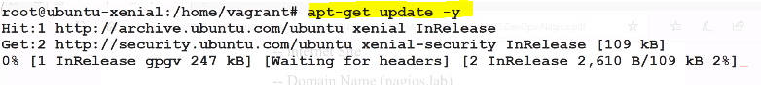

$apt-get install tasksel

$tasksel for GUI

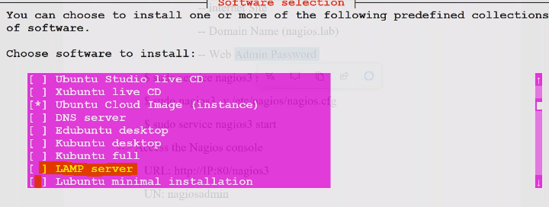

-select LAMP server and click on OK or use below command

$tasksel install lamp-server

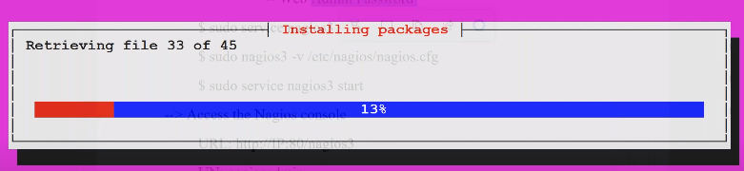

-while installing it will prompt for mysql password

-add password

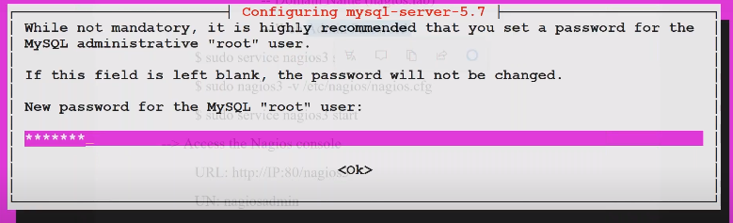

-*** this LAMP server is prerequisite for Nagios

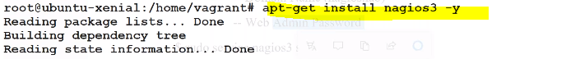

-while installation it will prompt for some configuration

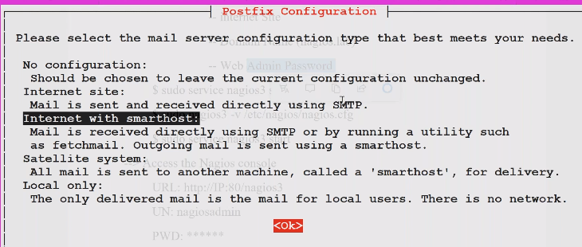

-Select the Internet Site is recommended for Nagios

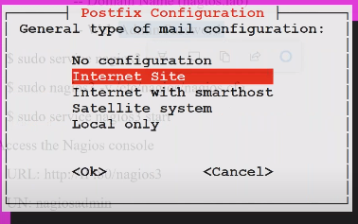

-we need to give the domain name, (we can use our organization name like thomson.com)

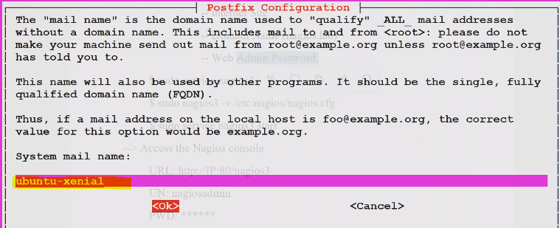

-give the dashboard password for nagios

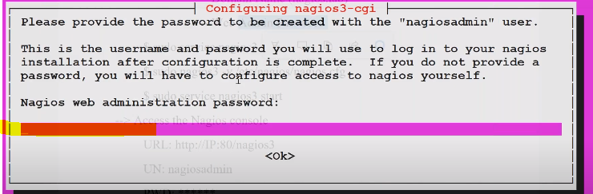

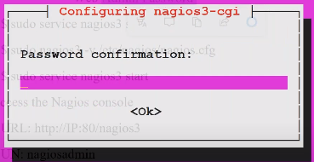

-while installing Nagios it will install plugins by default

-plugins are play important role in nagios

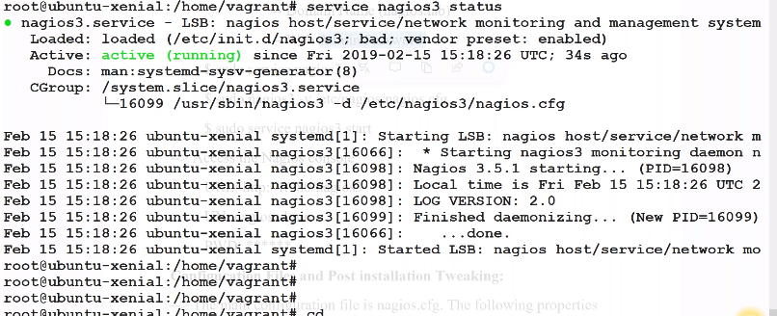



**Configuration Files and Post installation Tweaking:**

--> The main configuration file is **nagios.cfg**. The following properties

-- Log file location

-- The file location of commnds.cfg file

-- status update

-- status refresh interval

-- nagios user and group

--> Plugins location

--/etc/nagios-plugins/config/disk.cfg

--> Verifying Nagios config file

-- sudo nagios3 -v /etc/nagios/nagios.cfg (Syntax verification)

-Accessing Nagios tool

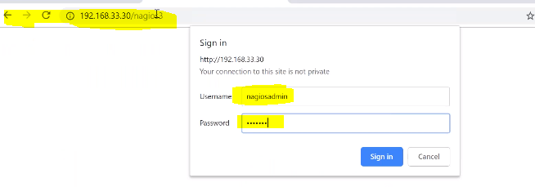

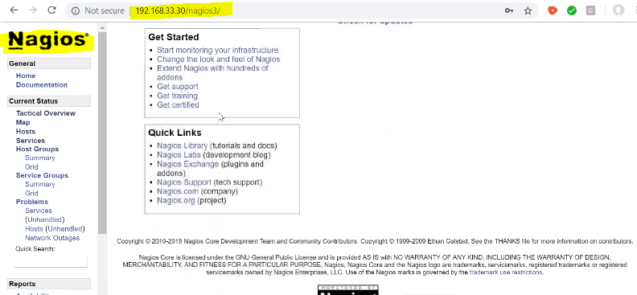

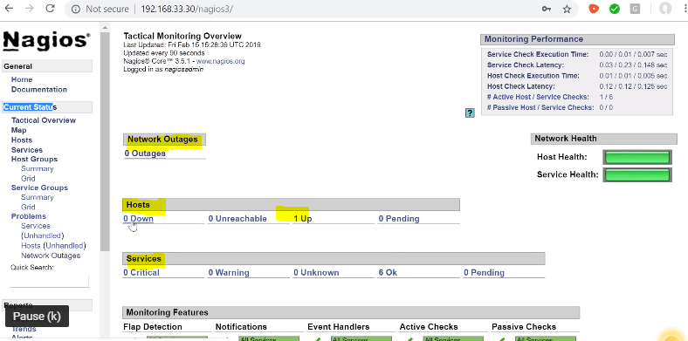

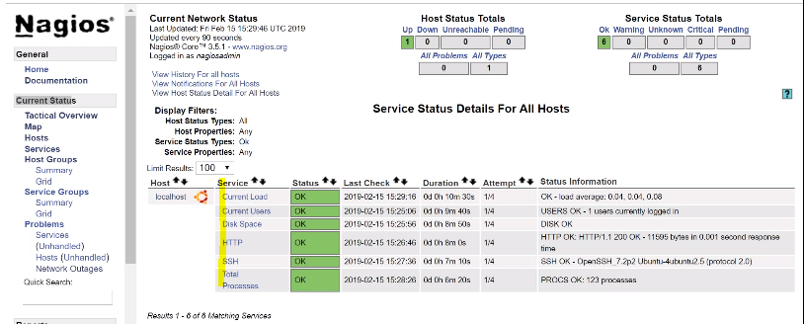

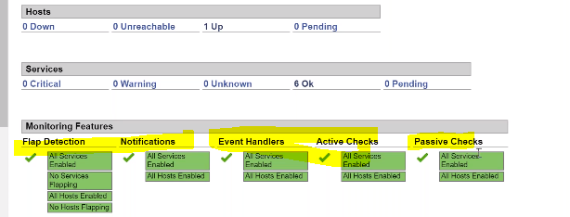

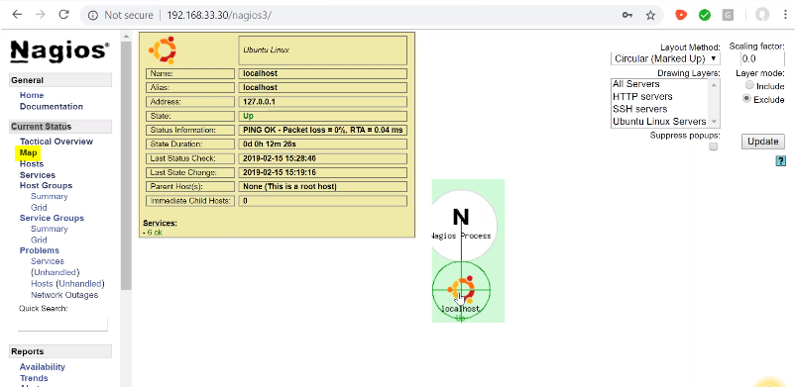

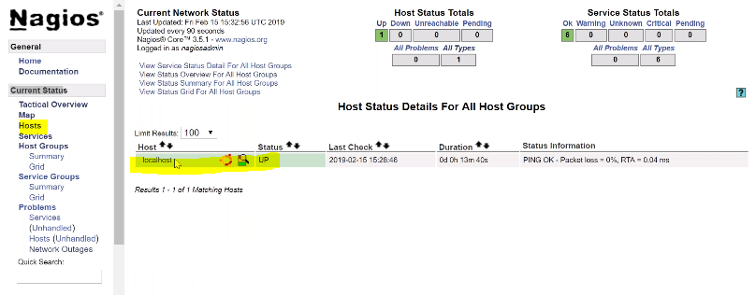

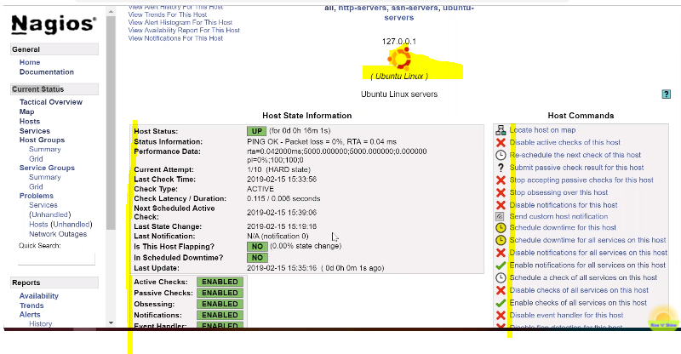

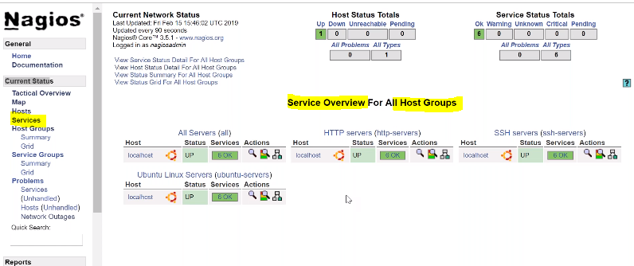

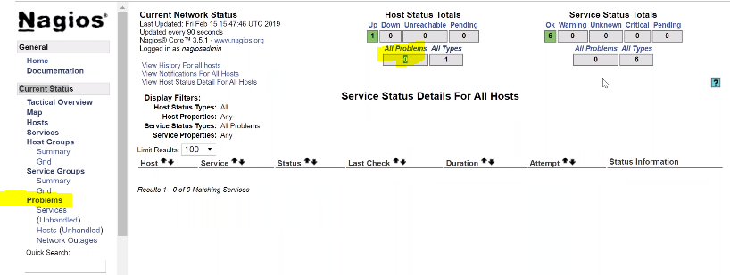

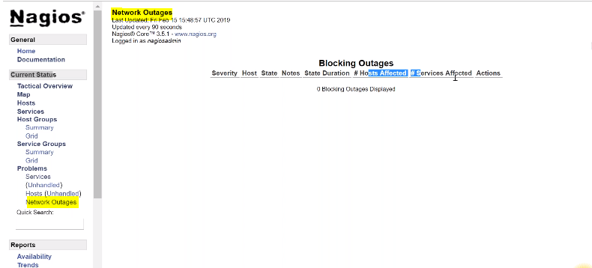

--> **Exception**:

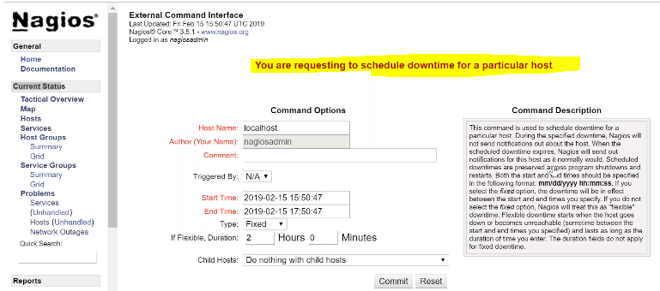

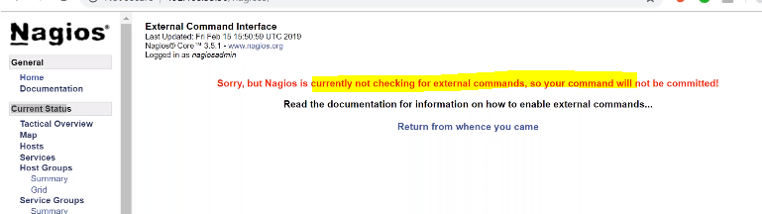

-- Nagios is currently not checking for external commands

-- Go to **nagios.cfg** file and check the **external_commands =1** should be one

-- -- sudo nagios -v /etc/nagios/nagios.cfg (Syntax verification)

-- restart the service (sudo service nagios restart)

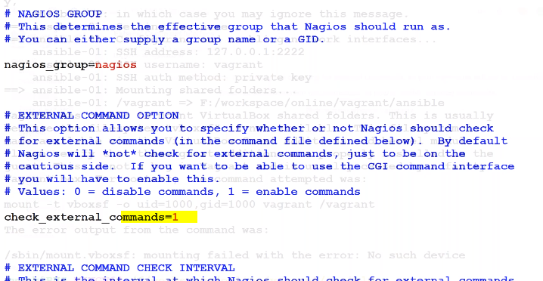

--> **Exception:**

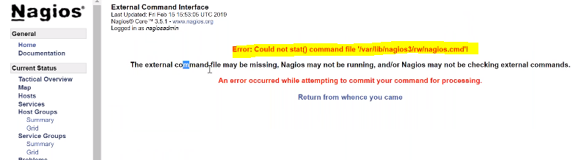

-- Could not stat() command file 'nagios.cmd' file

-- set the permissions

-- service nagios3 stop

--dpkg-statoverride --update --add nagios www-data 2710 /var/lib/nagios3/rw

--dpkg-statoverride --update --add nagios nagios 751 /var/lib/nagios3

-- service nagios3 start

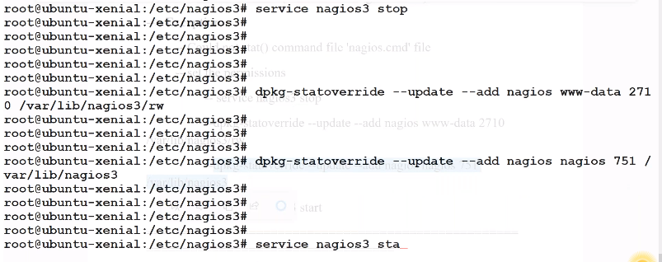

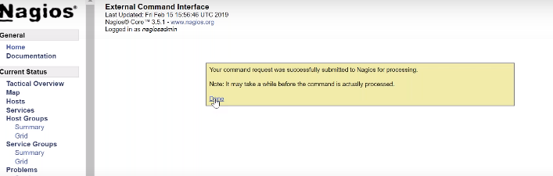

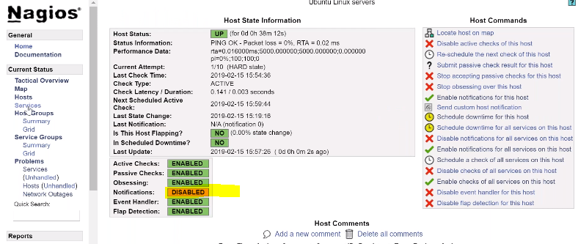

=====================================================================================

**Plugins:**

**-->** The commands location is /etc/nagios-plugins

--> The above commands refers the plugins which are located /usr/lib/nagios/plugins

$ ./check_disk -h (to get the complete help of the commands)

$ ./check_disk -w 10% -c 5% -p /

$ ./check_ping -h

$ ./check_ping -H 192.168.56.66 -w 0.10,1% -c 0.20,1% (milli seconds, packet %)

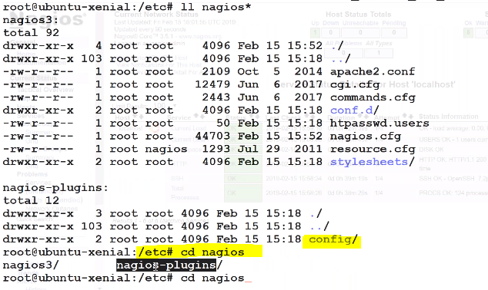

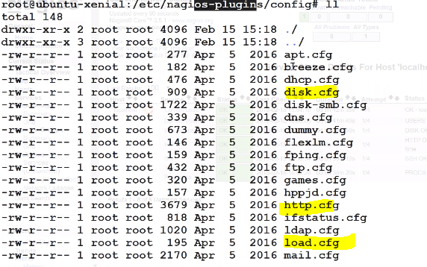

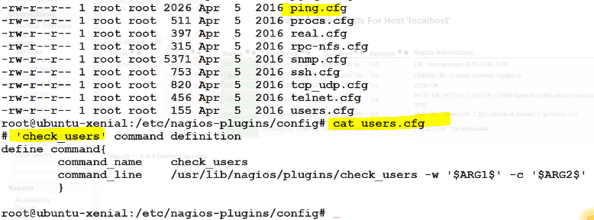

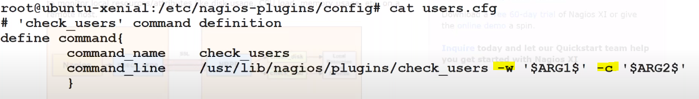

-w warning and message like defining 30% free memory means (70% utilization)

-c critical metric like defining 20% critical means (80% is available)

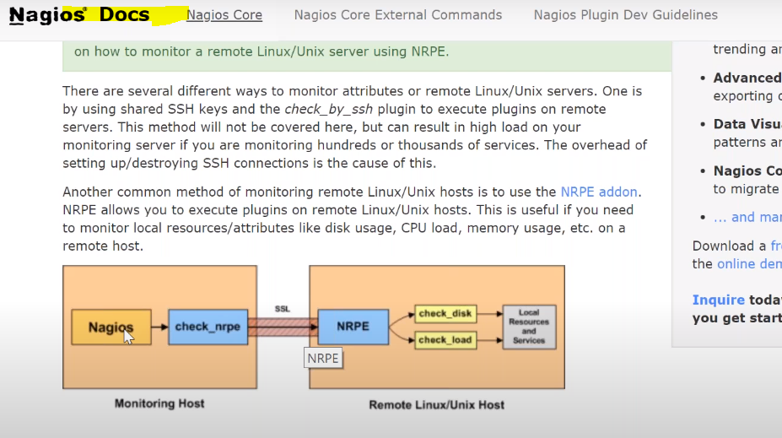

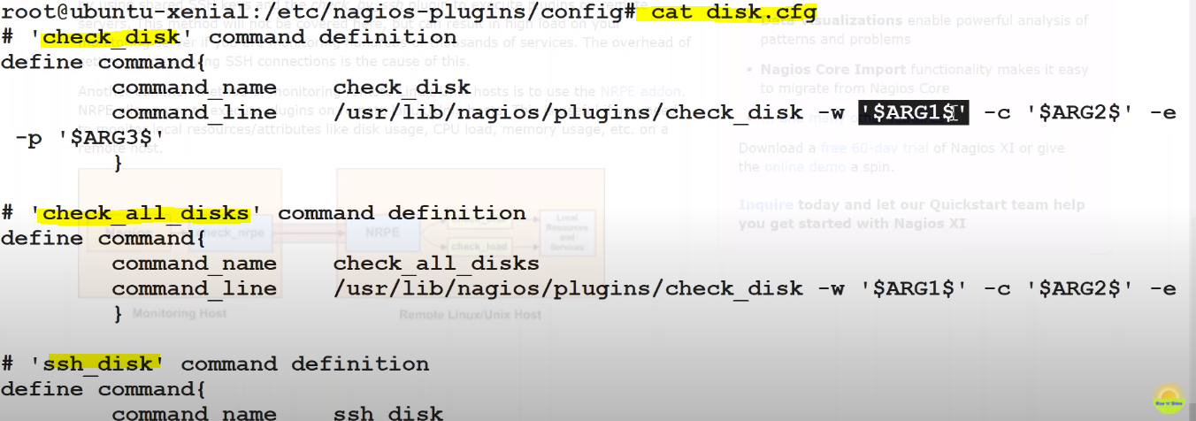

-these files are called as wrapper files and these are internally working with the nagios plugins

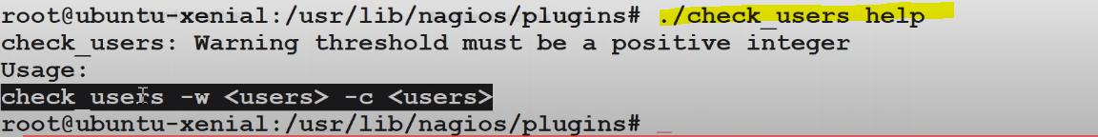

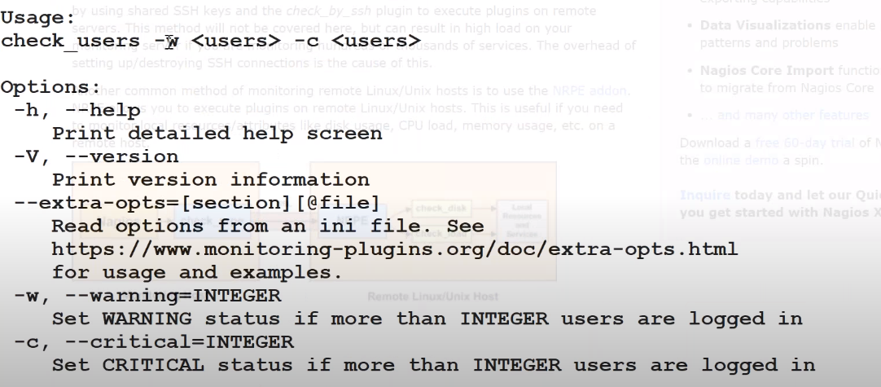



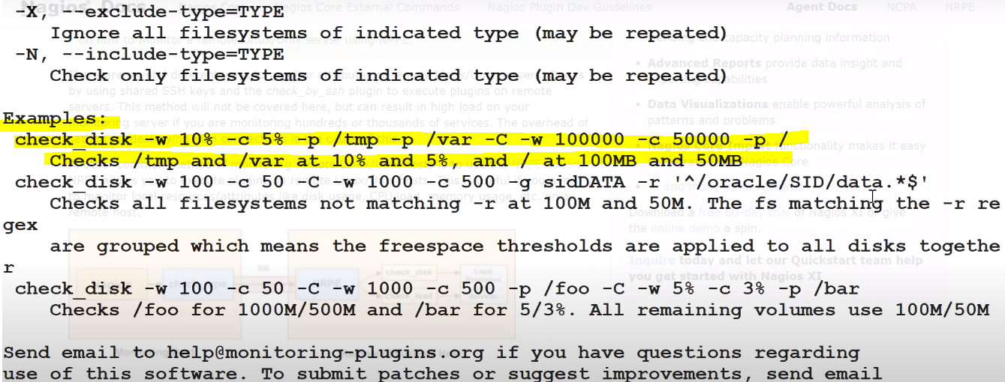

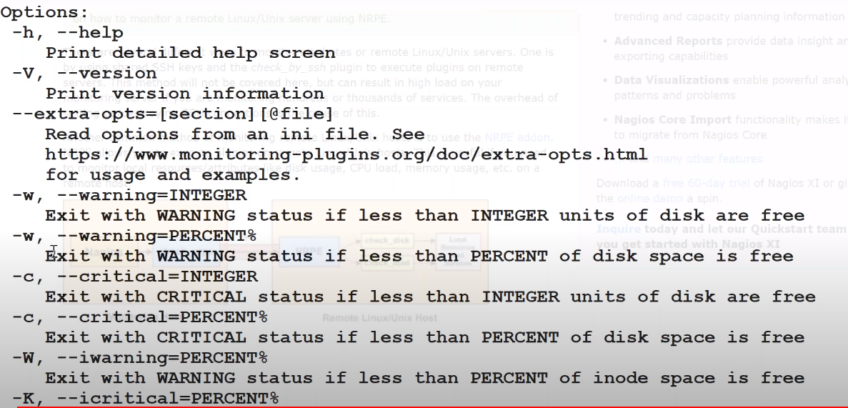

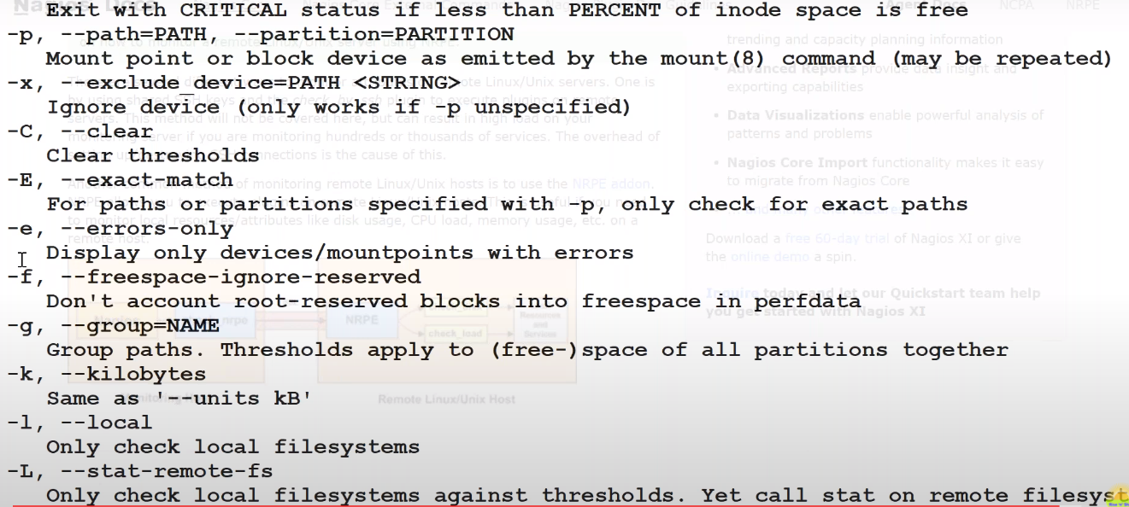

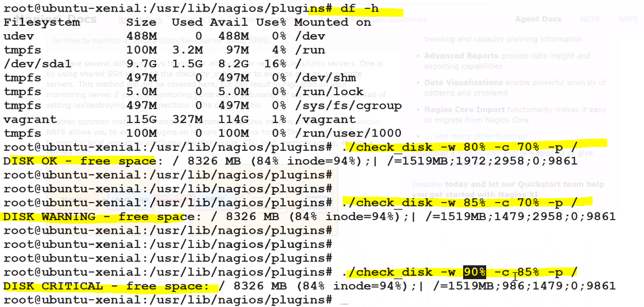

=====================================================================================

**Client Configuration: (registering the machines)**

- if we want to monitor 100 systems, we need to install below service in all the machines

-also need to install plugins as well

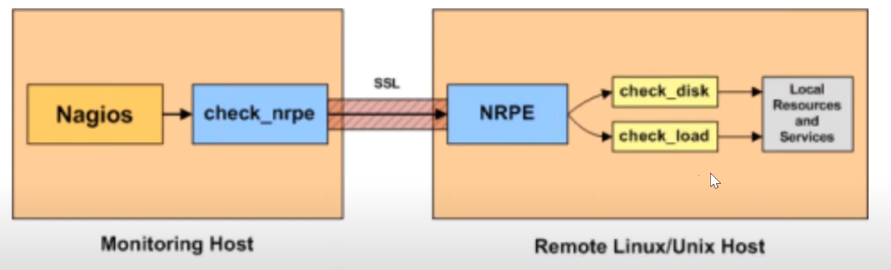

**Install NRPE Service**

*sudo apt-get install nagios-nrpe-server nagios-plugins*

**Configure NRPE**

After the installation is complete, edit the nrpe file */etc/nagios/nrpe.cfg*:

*vim /etc/nagios/nrpe.cfg*

... and add Nagios Server IP *192.168.1.9* to the *server_address*.

*server_address=192.168.1.9*

**Restart NRPE**

*service nagios-nrpe-server restart*

-installing nrpe in client machine

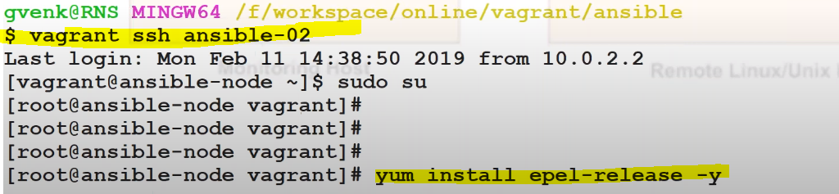

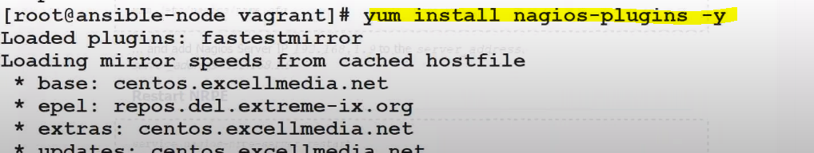





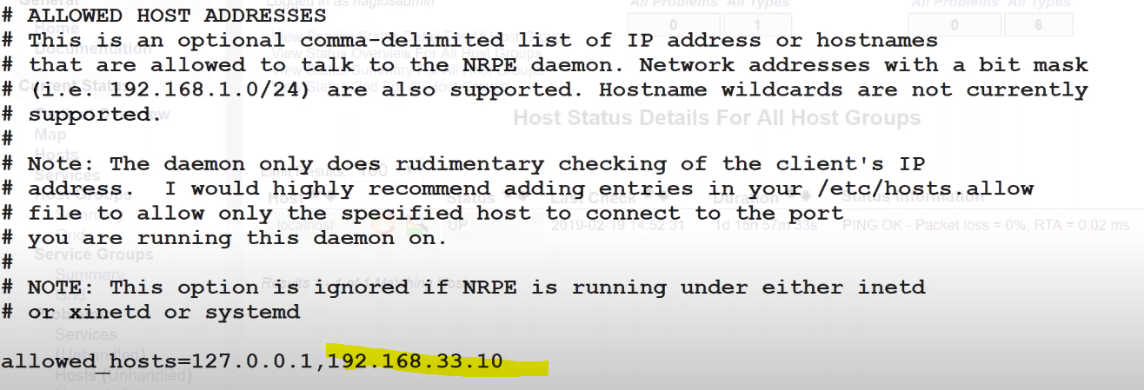

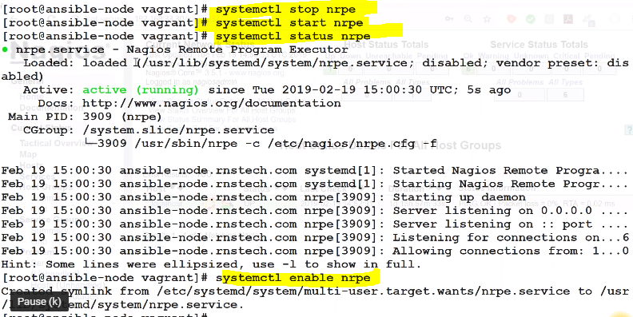

================================================

**Host Definitions:**

--> Go to /etc/nagios3/conf.d/

$ more localhost_nagios2.cfg (let's explore the Host)

$ more generic-host_nagios2.cfg (let's explore the generic host file )

Note: contact_groups should be defined in the contacts_nagios2.cfg

Note: Time periods should be defined in the 'timeperiods_nagios2.cfg'

--> Create one more cfg file to define new hosts (client.cfg)

$ vi client.cfg

define host{

use generic-host ; Name of host template to use

host_name clientHost

alias My Client Host

address 192.168.56.65

}

--> Let's restart the nagios

$ service nagios3 restart

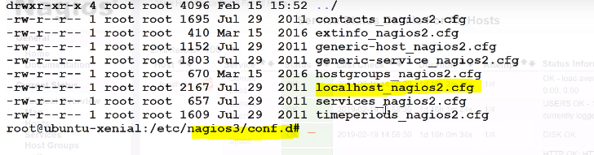

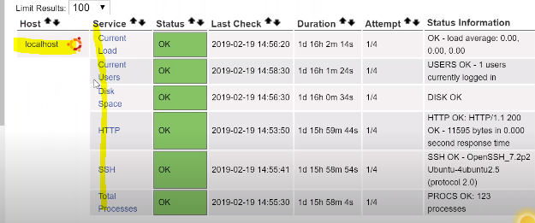

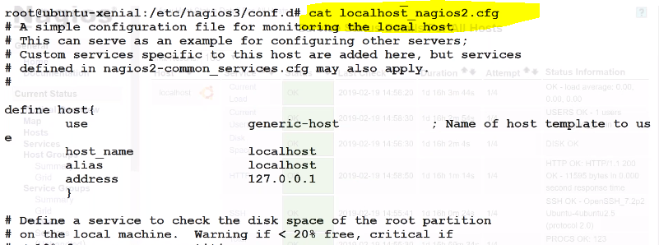

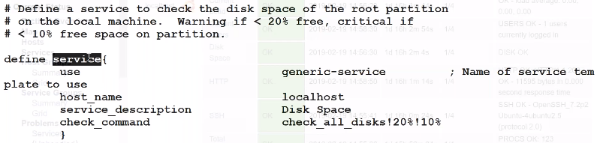

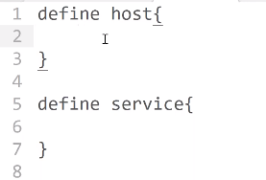

<https://library.nagios.com/library/products/nagios-core/manuals/?__hstc=118811158.33fb96a3970ddc2fae3085fbcace5b39.1637693292704.1637693292704.1637696163306.2&__hssc=118811158.2.1637696163306&__hsfp=2991284538>

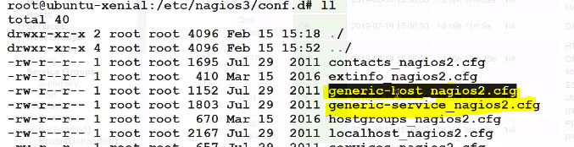

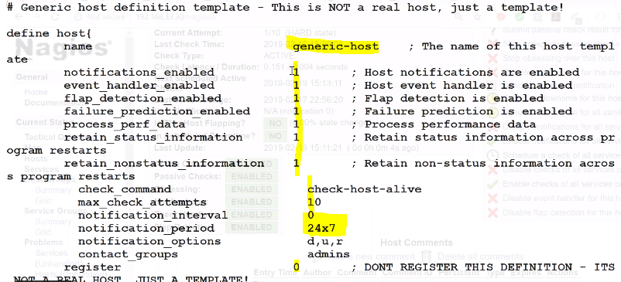

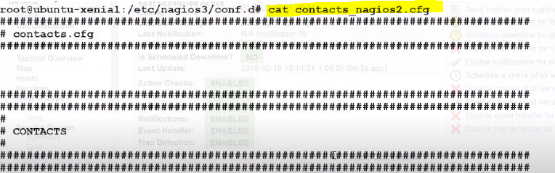

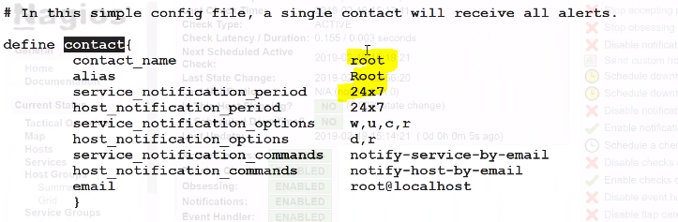

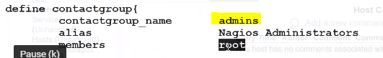

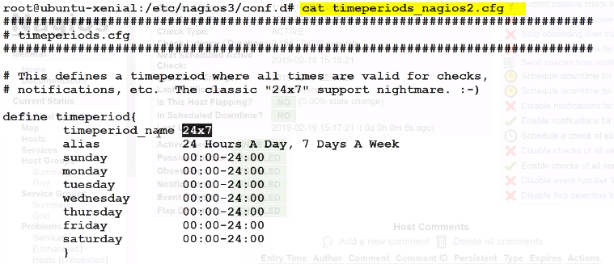

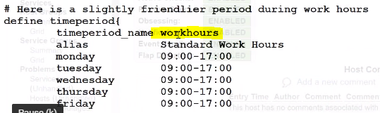

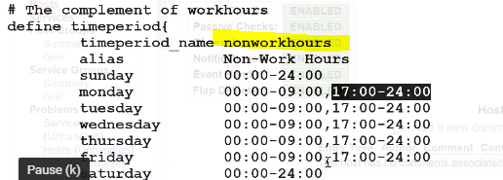

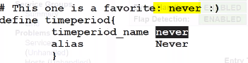

Services section:

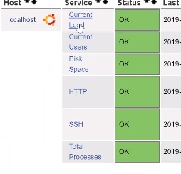

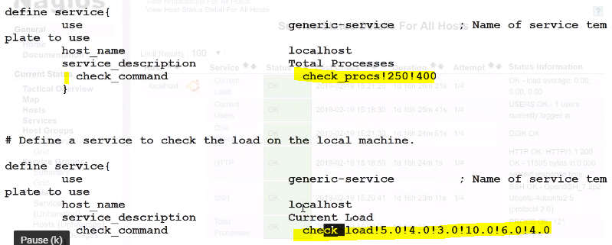

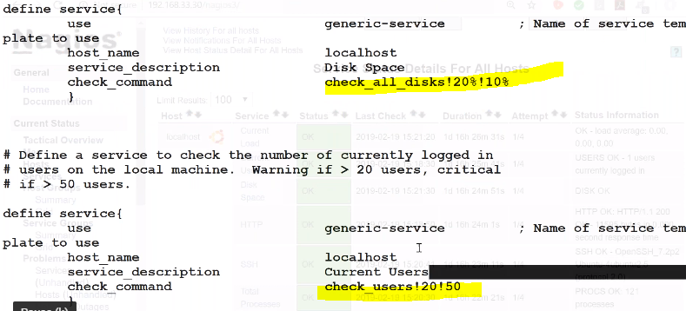

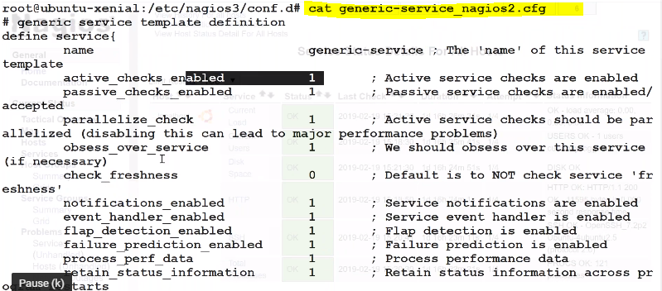

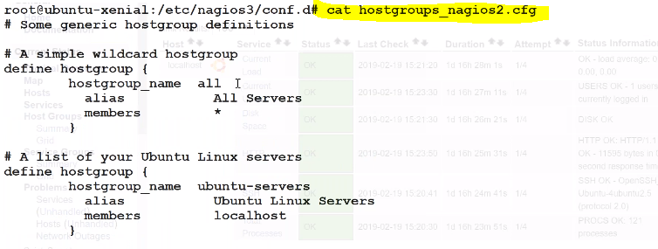

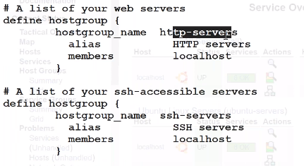

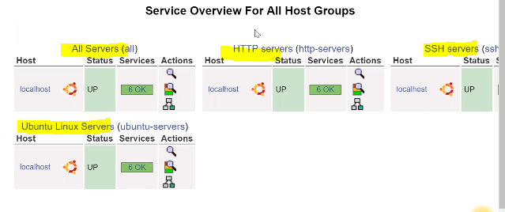

===========================================================================

**Service Definition:**

--> Go to /etc/nagios3/conf.d/

$ more localhost_nagios2.cfg (let's explore the Host template)

$ more generic-service_nagios2.cfg (let's explore the Service template)

$ vi client.cfg

define service {

use generic-service

host_name clientHost

service_description SSH

check_command check_ssh

notifications_enabled 0

}

define service{

use generic-service ; Name of service template

host_name clientHost

service_description Disk Space

check_command check_all_disks!20%!10%

}

--> Let's restart the nagios

$ service nagios3 restart

====================================================================================

--> open the /etc/nagios3/conf.d/contacts_nagios2.cfg

--> copy the contact element and add one more element in the same file

define contact{

contact_name admin

alias admin

service_notification_period 24x7

host_notification_period 24x7

service_notification_options w,u,c,r

host_notification_options d,r

service_notification_commands notify-service-by-email

host_notification_commands notify-host-by-email

email devopstestmail@gmail.com

}

--> Then add the contact name in the contacts Group in the same file

--> Save and Quit

Configure Email:

--> Go to /etc/postfix/main.cf

$ vi /etc/postfix/main.cf

relayhost = 192.168.56.65

(configure the IP address of the nagios server at relay network field)

--> restart the postfix

============================================================================

**-now we are going to add client machine (registering the client machine):**

-adding host:

$vi ansibleclient.cfg

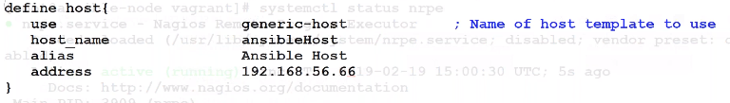

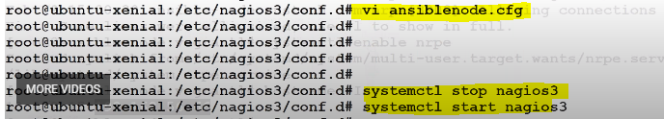

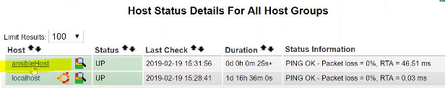

-adding service:

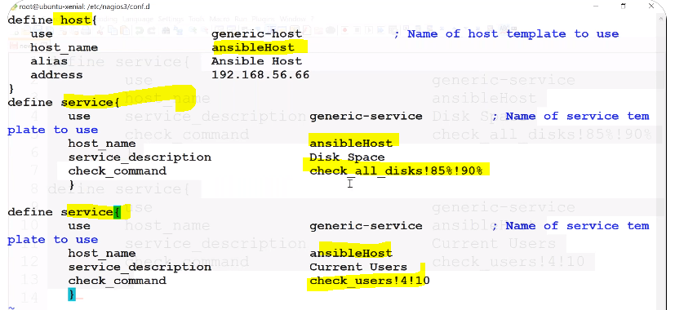

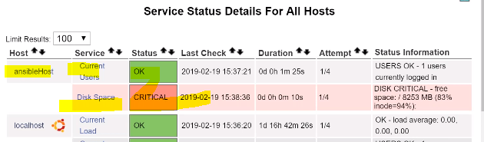

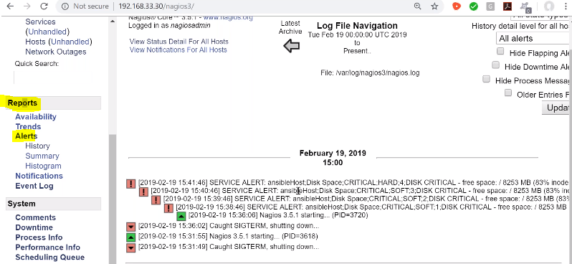

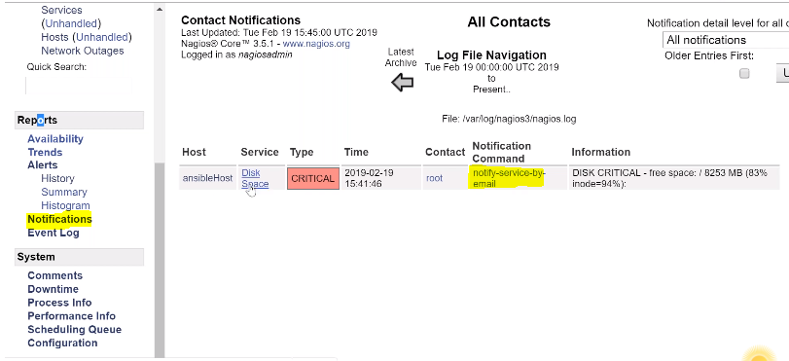

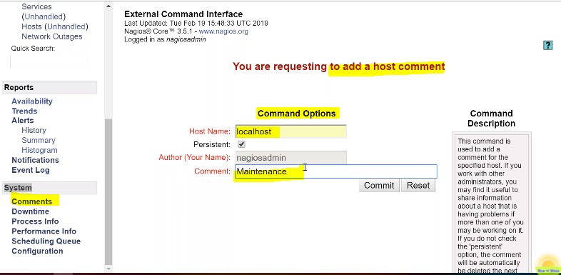

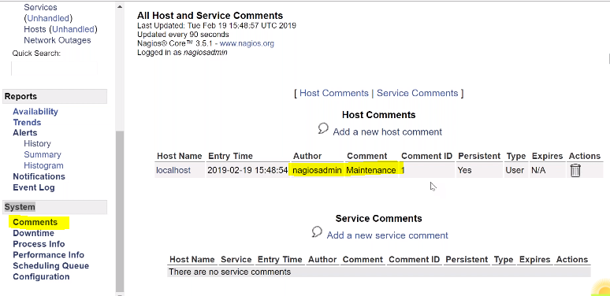

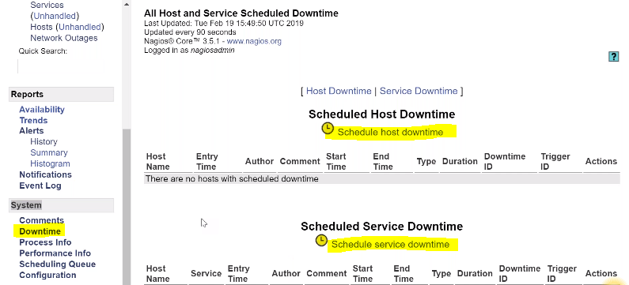

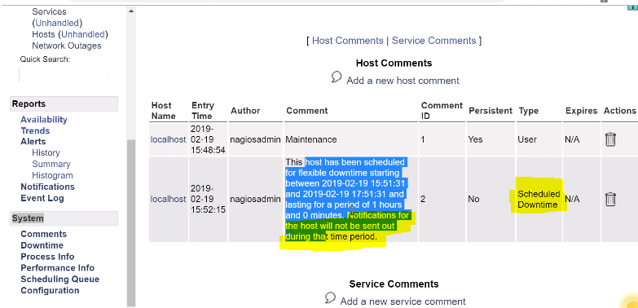

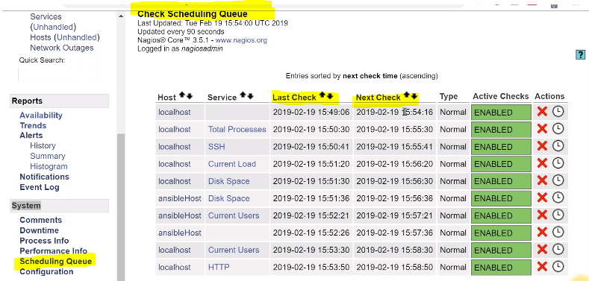

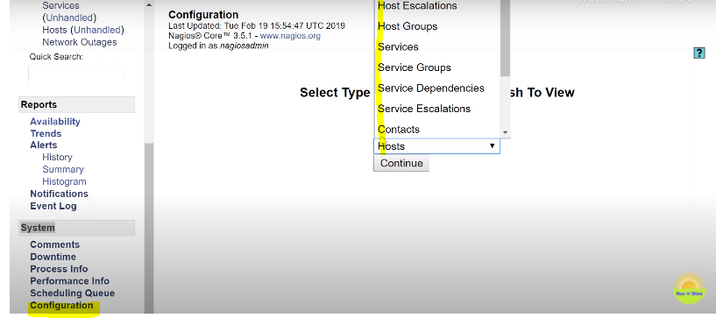

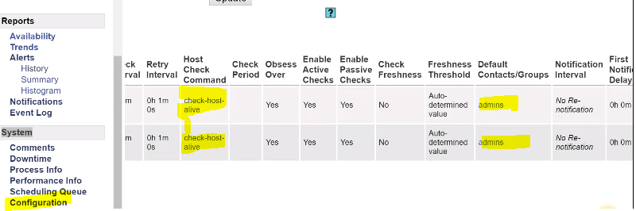

We can download readymade plugins in below location:

<https://exchange.nagios.org/>